



PRINCIPAL: Mr Damien Spencer

ADMIN OFFICER: Mrs Trisha Phillips

SCHOOL TELEPHONE: 47 777 132
FAX NUMBER: 47 777 389
EMAIL: admin@halifaxss.eq.edu.au
SCHOOL ADDRESS: 17 Victoria Tce
Halifax Qld 4850

Calendar for 2013

Term Dates

- Term 1 - Monday January 29th to Thursday March 28th
- Term 2 – Monday April 15th to Friday June 21st
- Term 3 – Monday July 8th to Friday September 20th
- Term 4 - Tuesday October 8th to Friday December 13th
Public Holidays affecting school routines
- Australia Day - Thursday January 26th
- ANZAC Day - Wednesday April 25th
- Labour Day – Monday May 6th
- Queen’s Birthday – Monday October 7th

WELCOME TO HALIFAX STATE SCHOOL
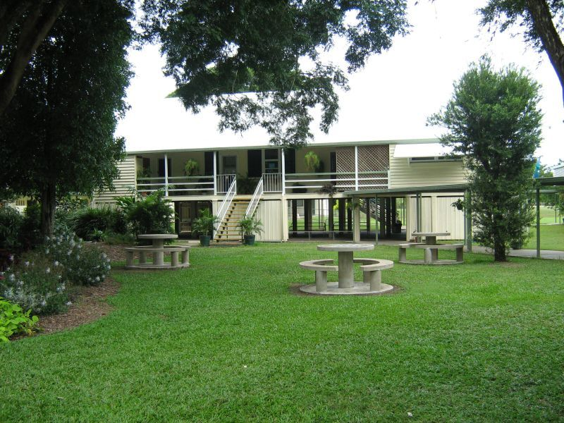
Halifax State School is a school of many proud traditions and prides itself on providing quality education for all students. We would like to engage all families in providing a culturally appropriate education for our diverse range of students.
This handbook is produced to dispel those questions, which arise in parents' minds as they contemplate the beginning of a new school year. Consequently, it outlines procedures your school has adopted for dealing with various situations. We welcome and encourage your interest and help in all aspects of school life and your child's education. Through cooperation and open communication, we can ensure that all children have their educational needs fulfilled. With the help and support of parents and the hard-working staff that we have, I am confident that 2008 will be a successful year of quality programs at our school.
Our goal at Halifax State School is to provide a quality education, which meets the needs, interests and abilities of students by emphasising the development of appropriate and relevant knowledge, skills and attitudes, while preparing the students for further education and for a valued role in society. These principles are in line with Education Queensland's 2010 Strategy as follows:
Over the next decade, the central purpose of schooling in Queensland should be to create a safe, tolerant and disciplined environment within which young people prepare to be active and reflective Australian citizens with a disposition to lifelong learning. They will be able to participate in and shape community, economic and political life in Queensland and the nation.
We look forward to a productive partnership with you and your child/children so that we may provide a Quality Education Service for each student at Halifax State School.

………………….
Damien Spencer

Principal



Our staff is currently as follows:
Principal - Years 3-7 Teacher | Mr Damien Spencer
Prep – Year 2 Teacher | Mrs Louise Currington
LOTE Teacher | Mrs Lugina DeMeio
Guidance Officer | Mrs Julie Cattoni
Teacher/Librarian | Mrs Dianne Shineberg
Support Teacher Learning Difficulties | Mrs Debra Giles
Teacher Aide | Mrs Jan Fuller
Teacher Aide | Mrs Karen Martino
Administration Officer | Mrs Trisha Phillips
Cleaner | Mrs Louise Jones
Groundsperson | Mrs Louise Jones



The school has an Annual Implementation Plan for which we seek input from parents, staff and students. The Annual Implementation Plan explains how the school will operate over the year. Parents are most welcome to peruse this document and it can be obtained by asking for a copy at the office to read and return. It is also available on the Halifax State School website.

At Halifax State School we employ the Explicit Teaching Model based on the I DO, WE DO, YOU DO concept. I DO activities see the teacher explicit teach concepts and model behaviours. WE DO activities are when students work with teachers and/or peers to consolidate new knowledge and complete activities. YOU DO activities require students to demonstrate understanding by completing activities independently. In the WE DO stage of learning, teachers employ feedback to assist students to move from what they currently know, to what they need to know. This is done using 3 levels of feedback (task, process and self-regulation level) depending on the expertise of the student. If you would like to discuss the teaching and learning approach, please feel free to contact the school.



At Halifax State School we value the following:
- The social, emotional, physical, ethical and academic development of the child.
- Individual and cultural differences.
- Programs that cater for individuals, making the best use of educational expertise and educational trends.
- Quality communication and interaction between student, parent/care giver and teachers.
- A smooth transition from pre-school to primary to secondary school.
- Opportunities for teachers to develop professional expertise.
These values are based on the following beliefs:
- The child, rather than the subject, is the first and constant concern of the teachers at this school.
- The child will be stimulated and encouraged to learn, by undertaking tasks leading to the development of independent, reliable judgement and initiative.
- Through the guidance and example of the teachers, the children will learn to co-operate with peers and adults, to lead and to follow and to work as a member of a team. They will discover and respect the abilities and differences of others and develop an understanding and tolerance, which will allow them to lead their lives harmoniously and function in our society.
- A sense of belonging to the school is fostered by the wearing of the school uniform through encouraging the children to care for their school and by participation in community activities.
- All children will be stimulated to reach their full intellectual development and to acquire the skills of communication, speaking, listening, reading, writing and numeracy. They should develop thinking skills, powers of critical judgement and skills to cope in a changing society.
- The children will be encouraged to participate in sporting and cultural activities.
- The teachers will strive to make their discipline as positive and formative as possible rather than suppressive.
- The teachers will draw on the resources of the community by taking the children into the community and bringing the community into the classroom. The school will be considered "open" to the parents, leading to a greater understanding by all stakeholders.
- The importance of learning technology in the teaching and learning process is recognised.
- The principles of effective learning and teaching and an inclusive curriculum are practised.


Our vision is EXCELLENCE IN EDUCATION, achieved through
- Excellence in learning and teaching
- A respected curriculum
- Fair and equitable practices
- Embedding social outcomes within the curriculum framework.
- Productive partnerships
- Responsible school management, and

- Responsible and helpful strategic management.

Halifax State School offers developmental programs in the Key learning Areas:
- Literacy (English)
- Numeracy (Mathematics)
- Studies of the Society and the Environment (SOSE)
- Science
- The Arts (Music, Drama, Art, Craft, Dance)
- Health and Physical Education
- Language other than English (LOTE – Italian) Years 6 and 7
- Technology is integrated within the curriculum for all year levels. All classrooms are resourced with computers and relevant software. The purchase of a Interactive White Board in 2008 has continued to help facilitate information sharing, knowledge and skills across all curriculum areas.
At Halifax State School we ensure that all students participate in a wide range of subjects and areas of interest. The school has developed school based curriculum documents, which are in line with the departmental requirements, but take into consideration the needs and interests of our students. These documents are reviewed regularly to ensure that the most effective methods are being employed.

We believe very strongly in the Principles of Effective Learning and Teaching, which are as follows:
- Understanding the learner

- Understanding the learning process
- Providing a supportive and challenging environment
- Establishing worthwhile learning partnerships
- Shaping and responding to a variety of social and cultural contexts
- Recognising the importance of an inclusive curriculum, i.e. one that considers and eliminates any barriers to learning and provides socially just access, participation and educational outcomes for all students.


- A high quality of education for your child.
- Our teachers are Senior Experienced Teachers- the best of the best.
- Our teacher aides have over 20 years’ experience
- One to one ipad ratio for students in years 4 to 7
- A caring, supportive environment.

The National Curriculum

Our school uses the C2C units in English, Mathematics, Science and History. In 2014 Geography will be introduced and over each new year a new C2C unit will be introduced replacing a previous key learning area.

English
Literacy is our core business at Halifax State School.
The goal of the English Syllabus Prep - 9 is to develop children's abilities to compose and comprehend spoken and written English fluently, appropriately and effectively - for a wide range of personal and social purposes. The development of high level literacy skills in the students is a key systemic target and likewise at Halifax State School is a high priority in the children's schooling. At each year level, participation in English should develop students' use of language in a wide range of literary and non-literary genres (styles) and in a wide range of social contexts. To assist students' use of English, programs will progressively refine their underlying attitudes, thinking processes, skills and knowledge within the context of language use.

Mathematics
The Prep - 9 Mathematics syllabus focuses on the nature and application of mathematics in the world around us. At the same time there is a concern for the emotional, intellectual and social development of each student. Each student is mapped and data collected to assist student’s mathematics learning of knowledge of concepts, processes and skills in a real world-learning environment. The aims of the syllabus are for students to develop:
- Numeracy skills including basic facts, operations, number problems, numeration used across mathematical areas such as measurement, shape, probability and statistics, time and money.
- Interconnecting concepts from both the numerical and spatial domains of mathematics.
- A broad range of mathematical processes including general thinking processes and problem solving.
- A positive frame of mind, which encourages initiative, co-operation and the application of mathematical concepts and processes in a logical and purposeful manner.

Information Communication and Technology
The school is connected to the Internet and is well equipped with computers. The school has a well-developed plan of Technology strategies and has skilled staff in this area. Each student is mapped on a developmental continuum to assess and evaluate student’s progress in Information, Communication and technology knowledge, skills and processes. Unlike the standard dial-in Internet connection you may have at home, the school uses a modified form of the Internet provided by Education Queensland that screens out inappropriate sites. Rigorous filtering systems ensure that the highest standards of protection are provided for your children.
In the rare event that an inappropriate site should slip through this process, it would still be extremely difficult for a child to stumble across or even locate such a site. At the beginning of the year, parents sign a form to indicate that they support the children using the Internet at school. Also at the beginning of the year, parental permission is required to allow children's work and photographs to be included on our web sites. The photographs are low-resolution photographs (scanned in low detail) and only first names are used for security purposes.

Studies of Society And The Environment
The objectives of this syllabus are to develop knowledge and understanding, academic skills, social skills, thinking processes, attitudes, feelings and sensitivities. At Halifax State School we value the diversity to be found in the community and use this program to encourage tolerance and understanding to ensure the students are active and informed citizens.

Science
The science strands are as follows:
- Science and Society
- Earth and Beyond
- Natural and Processed Materials
- Energy and Change
- Life and Living

Music
The Music Program aims to encourage all children in the appreciation, awareness and enjoyment of music. We welcome support from our parents and school community in assisting to make our music program both stimulating and rewarding. Throughout 2008 we had the services of a district EQ Music specialist, Ms Caroline Giles.

Art
The Art syllabus states that good artists discover, plan, do and evaluate. At Halifax we use this framework to plan activities that develop creativity, stimulate appreciation, develop a sense of self-evaluation and develop knowledge and skills in art.

Health And Physical Education
A new outcomes based syllabus has been developed based around the following strands
- Promoting the Health of individuals and Communities
- Developing Concepts and Skills for Physical Activity
- Enhancing Personal Development
Sport
The school has two sporting houses, to which all students belong: Emus and Kangaroos. Each year an ‘Emus and Kangaroos' Day is held at the school, when all students participate in a variety of athletic activities. Parents are encouraged to attend.
Following the Emus and Kangaroos Day, the whole school attends the district C Grade Sports Day. Students selected from this event can then attend the Barnes Cup and can be selected to represent the district further.
Swimming
In 2013 swimming was conducted from week 2 – 9 during fourth term. We received 1-hour swimming instruction blocks. All students from year Prep – 7 are involved.
Human Relationships Education
Halifax State School has a Human Relationships Education plan which is available for your perusal. This curriculum area is not taught as a separate subject but integrated across the other curriculum areas. Any parents who are concerned about the more sensitive areas of this program should discuss them with the class teacher or principal.

Languages Other Than English (LOTE)
All students in Years 6 and 7 receive instruction in Italian from a visiting Specialist Teacher for two 45-minute sessions per week. The main aim of this is to ensure that students have the opportunity to not only learn another language but to create greater understandings and tolerance between cultures generally. LOTE also has the benefit of creating a greater understanding of English through the analysis of language structure.

Please ensure a note to explain absences is sent to school with your child on the day immediately after any absence, as Education Queensland require an accurate record to be kept. A phone call or visit to explain absences is quite acceptable. Each week our Administration Officer enters the roll details onto the School Management Computer.

Qualified staff for minor injuries will administer First Aid. Parents will be notified of more serious injuries. We ask that all parents supply an emergency phone number and the name of your doctor.
The Administration Aide needs to be notified immediately of any changes of home or emergency phone numbers. The ambulance will be contacted in the event of extreme emergencies whether or not parents are subscribers.

Arts Council performances are theatrical performances held throughout the year by the Queensland Arts Council. The performances are held at the school.

Halifax State School has a detailed Responsible Behaviour Plan, which was developed with, and approved by Education Queensland. This Plan is based on providing a safe, supportive environment where expectations are clear, with consistent and fair enforcement of rules being demonstrated. As well as consequences, there are ongoing positive feedback systems in place and incentive schemes to encourage appropriate behaviours.
The structure of our Plan is based on the Glasser Theory where children are given choice; the behaviours they choose will attract either positive or negative consequences.
In both the classroom and the playground a series of colours are used. All children start each day on White. Bronze, Silver and Gold are the positive rewards, grey is a rule reminder, red indicates that a child has chosen more serious inappropriate behaviours and must complete a ‘Red Letter’ and take it home for parents to sign. In the playground a red card means that students may not be allowed back into the playground for a period of at least three days during play time and undergo training in making better choices of behaviour. Purple indicates that a child has chosen to continue demonstration of inappropriate behaviour; a parent interview is then organised and a behaviour plan negotiated. Purple 2 indicates suspension for 3 days or more.

Upon return to school the student then has a daily program whereby observation of behaviour is undertaken and recording after each session of school whether behaviour demonstrated is satisfactory or not; this observation period is from two to six weeks. Our ultimate consequence is exclusion from Halifax State School, and this will be considered once all other consequences have been exhausted.
We do prefer to focus on the positive behaviour demonstrated by our students and provide appropriate rewards for continued appropriate behaviour. In the 2008 budget an allocation of funding to support this program has been provided. We welcome your support and look forward to working with you and your child(ren).
Intervention From the time your child(ren) enter the school gate until they leave in the afternoon they are under the care of a very committed staff. All staff has the authority to apply both positive and negative behavioural consequences. The ultimate responsibility for the children lies with the principal. Parents should intervene only if no staff is nearby and only if students are in a situation where they could be harmed. Language used must be appropriate, calm and non-threatening. If physical intervention is required it should be restraint based only for accompaniment to the principal’s office.
Inappropriate behaviour outside of school, which would harm the good name of our school, should also be reported to the principal; conversely we also like to hear about the great things our students do.
A full copy of the Positive Behaviour Plan can be viewed at any time as each class teacher has a copy, one is held in the office, on the school website and the P&C also has a copy.




The school has a daily bus service for the students who live at Taylor's Beach. Queensland Transport provides this service. Subsidy for driving students to school, if distance is involved, is also available and the details may be obtained from the office. The bus delivers the students to school at 7.40 am. Students are required to remain seated under the Covered Tuckshop area until a teacher allows them to play. The bus collects the students at 3.45pm.

The school camping program involves students from Years 4 to 7. All school camps and excursions are conducted under the Departmental guidelines. Camps are scheduled every year.


Open and regular communication between the school and its client families is an essential element of education. At Halifax State School, this will be continued through a fortnightly newsletter, issued every Tuesday that contains important information and reminders. The P&C also uses this newsletter to keep you informed of their activities. Parents are invited to submit material for inclusion in our newsletter.
The school webpage is also a source of documents, articles and information.
The school uses a smart school app to keep parents up to informed, this can be downloaded from the apple itunes store and android in the near future.

Parents are most welcome to use the school grounds with their children after school hours provided they have personally sought permission from the principal and collected an authorisation note. This note will remain effective until the end of the year. Areas of the school grounds that can be used include the following:
- Playground

- Soccer Ovals
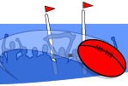

- Tennis Court area
- Cricket Nets
All other areas of the school are strictly out of bounds (including climbing any trees). If children/parents are found using areas other than those designated or using areas inappropriately, rights to use the school grounds with your children after hours will be revoked. Permission to use the school grounds after school hours does not mean that the school can be used as a short cut between roads. Permission to use the school grounds after school hours requires parents to be present with their children (i.e. on the school grounds, not watching from home).



The rule of "No Hat, No Play " is enforced at this school. If a student does not wear a broad-brimmed or bucket hat their play areas are confined to under the building, library and the undercover tuckshop area for protection from the sun. The school has a school bucket hat which students are requested to wear.


The class teachers set homework for all children.
Regulation 19 states – A teacher may require a pupil to undertake home study which may occupy such amount of time as a principal may decide is reasonable in the circumstances”.
Times Specified:
- Year 1-3:- 15 minutes, increasing to half an hour in third term. Generally no written work.
- Year 4/5:- Half and hour, increasing to 45 minutes in second term.
- Year 6/7:- 45 minutes, increasing to 1 hour.
We believe that homework serves the following purposes:
- It sets good study habits for the children.
- It allows the parents/guardians to see what the students are doing at school, as well as how they are extending their learning.
- Many of the academic areas of schooling are best developed through practice, e.g. reading, and this practice can be supplemented in the home.
- Research shows that children benefit from the interest shown in their education by their parents/guardians.

Students with leaning difficulties are supported both, in the classroom, and by visiting learning support teachers. Where necessary guidance support is available.

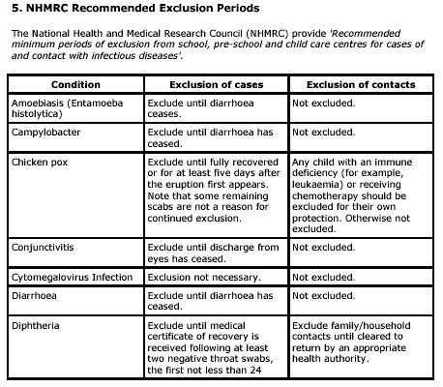

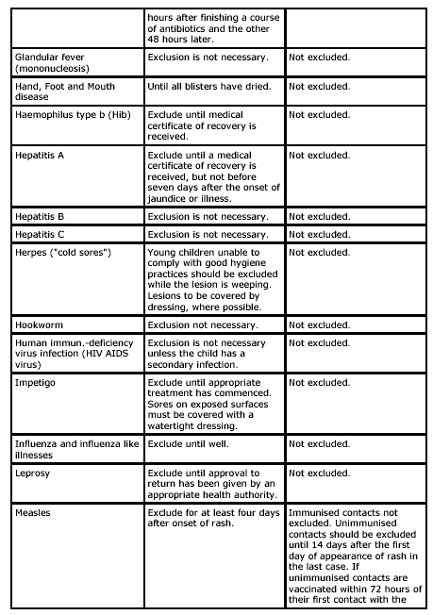

A refrigerator is available in the classrooms for storage of students' lunches.


Medication can be administered to a student only if accompanied by the student's name, date, doctor's written instruction (eg. prescription item) and a permission note from parents.

The Education Department has a policy of non-contact time for teachers. Yr Prep-7 teachers will be out of their classrooms for two hours/week for planning and assessment. During this time either a specialist teacher, or another member of staff will follow the program of the class teacher to ensure continuity in the program will teach the class.


The Administration Officer works at the school on Monday, Tuesday, and Thursday.

We actively encourage parents to be involved in school activities. We value parental support in the classrooms and other aspects of schooling.

School reports are issued at the end of each semester, with a parent teacher interview being held at the end of term 1 and 3.

In 2014, we will be running multi-denominational religious education.

In August each year, Education Queensland undertakes a survey of Parent, Student and Staff Opinions. This information is used to both commended performance in good areas and also show areas for improvement. All responses are anonymous.


Please note that children are required to wear their shoes for safety reasons for all practice at the school except for long jump and high jump due to the nature of these events and the fact that the ground is checked for any dangerous objects. Please ensure that your child comes to school each day with running shoes (not thongs or sandals) as they will not be allowed to participate in the running or sports events. On the actual sports day at George Day Oval (which is well maintained and checked for minor dangers) parents may choose for their child to not wear shoes provided they have indicated on the generic permission form at the beginning of the year.


Halifax State School prides itself on ensuring that children are protected from harmful UV rays and has been formally recognised by the Queensland Cancer Foundation as a Sun Smart School. Our school has considerable shade created by large trees around the school. There is also shade provided under the main building and the undercover tuckshop play area. Children can also use the library during lunch breaks. Our school also has a policy of no broad-brimmed hat, no play in the playground. Students may play in the undercover area, under the main building or in the library. . Sunscreen is provided in the classrooms for the students (and staff room for the teachers). The lunch break has also been moved earlier (11.00 - 11.45) to reduce risk from the sun. Children also learn principles of sun safety in the classroom as part of the Health and Physical Education Program.


The school has a tuckshop that operates each Tuesday and is staffed on a voluntary basis. If you are able to assist in the tuckshop please let us know.

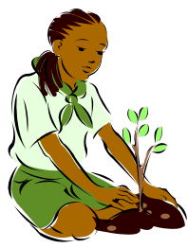

Girls' Uniform: Jade polo shirt. Black pleated skirt or Black Shorts.
Boys' Uniform: Jade polo shirt . Black shorts.
Interhouse Sports: Emu House - Yellow t/shirt Kangaroo House - Red t/shirt
Shoes: Black shoes or sports shoes
Hats: Halifax State School black bucket hat

The 'Year 2 Net' is a term used to describe statewide diagnostic procedures that ultimately provide additional funding and support for those students who require assistance in the areas of reading, writing and numeracy. Parent information handbooks can be obtained from the school and these are handed out with each year 2 net report.

These are national tests conducted across Australia with the results being conveyed to the parents through way of a report sheet.


Uphold the principles of the Code of Conduct:
- Care


- Cooperation
- Courteousy
- Commitment

- Children may not enter the school grounds before 8:30am unless prior arrangement has been made with the principal.
- Bus children or children authorised to arrive prior to 8:30 am must remain seated under the covered tuckshop area until given permission to leave.

- No child is to leave the school grounds without the permission of a teacher. The teacher is to countersign and date the note. The child is then responsible for showing the teacher on duty the signed note prior to leaving the school grounds.
- Children must leave the school grounds immediately after school is finished unless waiting for a bus or being involved with sporting practices, or other teacher supervised activities.
- Students may put their lunch in the fridge and bags in the racks upon arrival and then must move straight back outside.
- No child or adult is permitted in the school grounds out of hours, weekends or holidays without the written permission of the Principal.
- Bicycles must be wheeled into the school grounds.


7:40 am Bus students arrive
8:15 am Bus students to freshen up
8:30 am Arrival time for non bus students
8:50 am | Line Up Bell - Toilet, Drink, Wash Hands, Assemble ready to enter school.
8:55 am | Enter Class for Morning Session
11:00 am | Lunch Commences
11:15 am | Play bell
11:40 am | Line Up Bell - Toilet, Drink, Wash Hands, Assemble ready to enter school.
11:45 am | Enter Class for Middle Session
1:30 pm | Afternoon Tea Commences
1:55 pm | Line Up Bell - Toilet, Drink, Wash Hands, Assemble ready to enter school.
2:00 pm | Enter Class for Afternoon Session
3:00 pm | Dismissal
FIRE DRILL
A continuous ringing of the bell is the fire alarm. The evacuation procedure is displayed in each classroom. Fire Drills are conducted once per term. The School also has a “Lock Down” procedure where the whole school is locked down (staff and students) in case of Chemical spill etc. The Lockdown is indicated by intermittent ringing of the bell for at least a minute.

- Children are not permitted in the classroom during lunch breaks or before or after school without permission.
- Students may use the library before and after school and during the lunch breaks when a teacher is present in this room. Only quiet activities in the library. A full list of library rules can be found in the library.


- Walk on cement, verandahs and in buildings.
- No broad brimmed hat, no playing in the playground. Students will be only permitted to play under the building or the tuckshop shed.
- No closed in shoes, no playing in the playground. Students will be only permitted to play under the building or the tuckshop shed.
- Try to be friendly towards your fellow mates at all times.
- The walkways are to be used as a means from one area to another not as a play area.
- Play in designated areas of the playground. Areas that are out of bounds include: behind the classrooms (i.e. between the classrooms and the principal's residence); around the maintenance shed; roofs; reaching distance of the horse fence; the carpark; bike racks and the rubber tree.
- The adventure playground must be used in a safe manner.
- Balls are not to be kicked against the tuckshop wall with the panel doors.
- Students wishing to use the tennis court for tennis get first choice, the soccer field for soccer get first choice, the netball courts for netball get first choice, the undercover area for skipping get first choice, under the building for handball get first choice.

- The lunch break is from 11.00am - 11.45am. Children must remain seated under the play shed until the teacher instructs the bell monitor to ring the bell.
- Lunch boxes are to be put away before going to play.
- After the afternoon lunch break children will line up in a quiet and orderly manner under the Administration Block.
- Lunch areas and general school grounds will be kept clean and tidy at all times.
- Students are not to swap or share lunches.



- The sports room will be under the supervision of a monitor from the upper grades.
- Whoever takes sporting equipment out is responsible for its return.
- Sporting equipment is to be used sensibly and any breakages reported immediately.
- If sporting equipment goes out of reach eg on roof, out of school grounds a teacher needs to be notified so the appropriate means of retrieval can be determined.

- Students are not to give away items to other students.

The students are allowed to leave the school grounds during school hours, unless in the company of their parents. Parents who would like to pick their child up early from school should sign the ‘Early Departure’ folder before leaving.

Children who are considered for the Preparatory year must turn five (5) years of age by June 30th 2012.

Birth Certificates or some formal documentation must be produced when enrolling Preparatory students.

If for any reason your student is unable to participate in activities (EG swimming, sport) please forward a note to the class teacher on the day of the scheduled activity.


Water pistols, guns and caps, matches, pocketknives, chains, chewing gum and any objects considered dangerous will be confiscated. (Such items may be reclaimed by parents or guardians, but will not be returned to children).


The only items of jewellery and valuables that may be worn are watches, sleepers, studs and one friendship ring. Any other item of jewellery worn will be sent to the office where it can be collected by parents after school.


The school allows usage of a telephone by a child at the discretion of Administration. The situation needs to be both urgent and important. Calling for homework left at home, or to arrange to play with a friend after school is not permitted. MOBILE PHONES are NOT permitted on School Grounds by a child.


The Parents' and Citizens' Association is made up of a hard working and dedicated core of parents. The main aim of the Association is to provide the resources and support needed for our children to receive the best possible education, in a safe and supportive environment. The main focus for the Halifax State School's Parents' and Citizens' Association over the past few years has been to air-condition the classroom, library and pre-school as well as providing software to automate the library. Now that these projects have been completed the P&C is supporting the school in new ways including working on the repair of the tennis court.

The P&C assists the school in the following ways.
- Assists with general maintenance and odd jobs around the school through working bees.
- Assists with small projects around the school.
- Assists with school functions and events.
- Gives input on school direction.
- Co-funds the cost of camps and excursions to make the cost manageable for all students.
- Funds an end of yearbook prize for every student.
- Funds end of year graduation gifts for the students.
- Gives a contribution each year towards new resources for the students.

In order to assist the school in the ways outlined above the Parents' and Citizens' Association has a number of fundraising events during the year including:
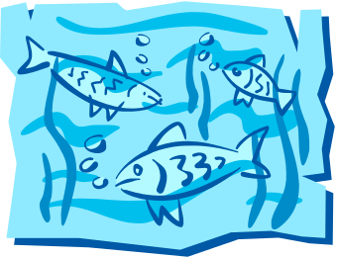
- Three markets throughout the year in the school grounds
- Weekly raffles at the local hotel
Ways In Which You Can Help
There are numerous ways in which you can help your P&C Association and in turn support your school and your children. Below are a few suggestions you may wish to try:
- Offer your assistance at one of the fundraising events throughout the year.
- Attend P & C Meetings

- Offer your assistance at a working bee
- Offer your assistance with tuckshop

Tuckshop
At the beginning of each year a form will be sent home asking for voluntary helpers in the Tuckshop. In particular we are searching for Workers (those people to actually work on the day) and Bakers (those people who provide 2 dozen small cakes). A roster is made up and usually you are required to work or bake every 6 weeks. If you work on tuckshop the day begins at 8.30am and usually finishes at 2.00pm on a Tuesday. You may choose either to work or to bake. Some people choose to do both.
P & C Meetings
The P&C Association is headed by an executive of a President, Vice President, Secretary, Treasurer and Tuckshop Convenor. All positions become vacant at the end of each year and we are always looking for new people with new ideas. Being on the executive is very rewarding and keeps you in tune with what's happening in your school and your child's education. In 2013, the P&C met on the second Tuesday of the month at 3.30pm in C Block, however the day may change according to the suitability for members. Everyone is encouraged to attend to support all aspects of the school. Parents and Citizens Association membership is open to all persons over the age of 18 who have an interest in the progression of our students and our school. Come and help continue to make Halifax State School a great place to learn and play.

For any further information, please contact the school by phone, email or come and see us. We look forward to creating a strong, productive and enjoyable relationship with you and your child.

